How to cut audio/videos in sony vegas

When you have opened up the program it should look like this:
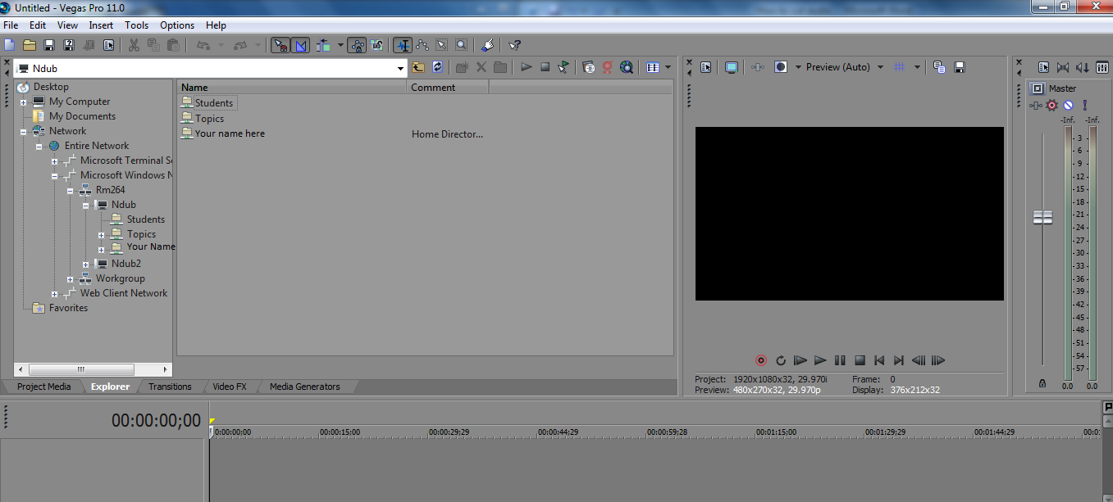

To add in a video/audio, look under:
Network
- Entire Network
Microsoft Windows Network
->Room 264
->Ndub
-> (Your student folder)
-> (Place you have saved the audio)

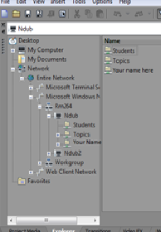

When you have located the one you want to use drag it in the area where the red arrow is showing.
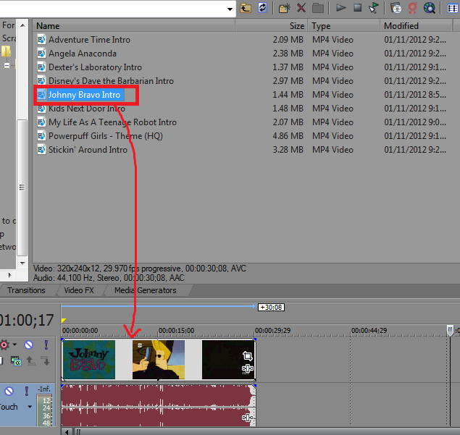
Drag it to the start of the timeline. Drag the yellow pegs, located above the timeline, around the video. Make sure you do this because the program will only save whatever is in the pegs.
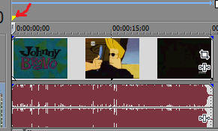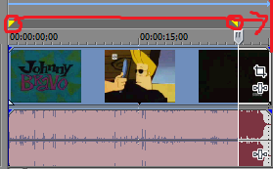

The Marker, circled in red, shows what frame is currently playing in the preview window. This can be moved by either dragging it or by using the arrow keys. You can also use this when you are animating a scene because it will help you indicate what frames you need to paint.
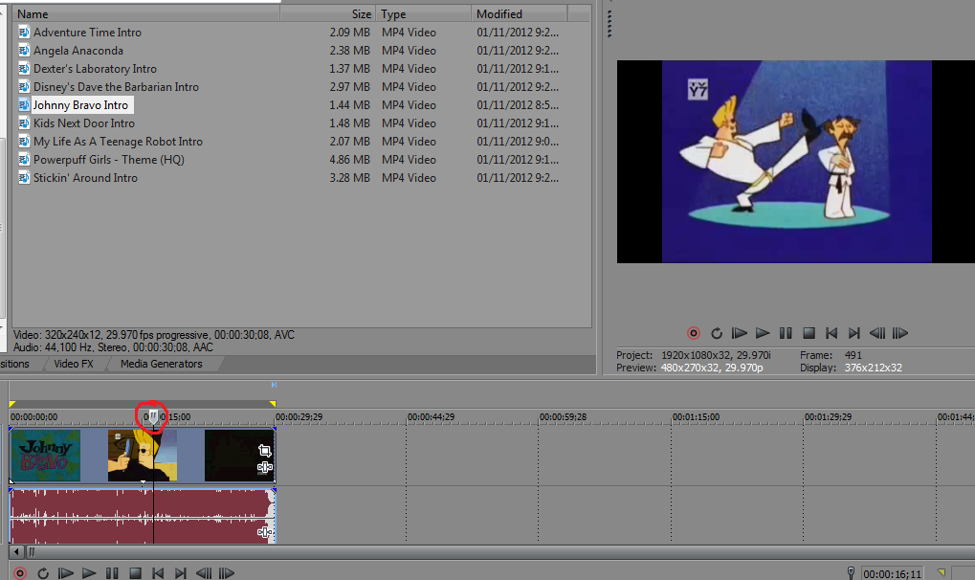

Splitting
Splitting the audio will help you add in the audio of want you want the characters to say in the short scene when you are clicked on. It is helpful to use headphones so you will know where to cut the audio.
Place the marker in the beginning of where the dialog starts. Now to spit it either go to Edit and select split (on top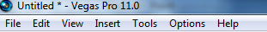) or you press “S” on your keyboard. Either way will work the same. Once you’ve done that it should look like this:
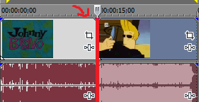
Right now you have 2 separate blocks of the audio. With the unwanted parts of the audio just simple spit the object again and press delete. In the diagram below, I have already chosen where I want the audio to start and end, and I have separated it from the rest (circled in red). Now all I need to do is to simply click or double click on the unwanted area and hit delete (circled in green). Make sure you drag the audio to the beginning of the timeline.
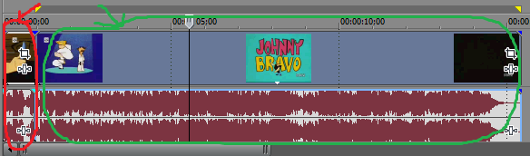

You can also zoom into the timeline by scrolling with your mouse. This is very helpful when you are trying to find a specific frame for the dialog and when animating.

